IT2120 - Probability and Statistics

Name: Andishan V

IT No: IT24103772

Exercise 1

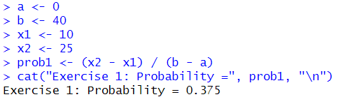

Exercise 2

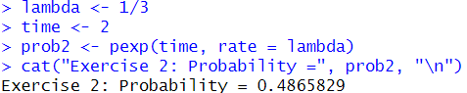

Exercise 3

